MRMS Design Document

Document History
Version | Date Issued | Author/Department | Comments
Draft | 03/11/2025 | Yoseph Mekasha Akalemariam | MRMS Technical Guide v1.0 (13 May 2022) used as source
1.0 | 21/04/2026 | Pritam Pawar

Contents
1. System Context & Assumptions 3
1.1 System Overview 3
1.2 System Context 3
1.3 System Boundaries 4
1.4 Environments 5
1.5 Assumptions 5
1.6 Context diagram 6
2. Architecture Overview 7
2.1 Tenant Topology 7
2.2 Component Overview 7
2.3 Component Interactions 8
3. Data Architecture 9
3.1 Overview 9
3.2 List & Library Descriptions 9
3.3 Data Relationships 10
3.4 Data hierarchy diagram 12
3.5 Data Lineage 12
3.6 Data Dictionary 13
4. Process & Workflow Design 14
4.1 Resolution Lifecycle 14
4.2 PBI Entry & Approval Stages 15
4.3 Oral Statement Generation & Approval 17
4.4 Revised Estimate Generation 18
5. Configuration Artifacts 19
5.1 Overview 19
5.2 Workbook Sheet Groups 19
Group 1 — Tabs Update Guide 19
Group 2 — Reference Lookup Tables (annual) 19
Group 3 — Cost Rates (per entity/budget section) 20
Group 4 — Approval Chain Configuration 21
Group 5 — Form Configuration (per entity/section) 23
Group 6 — Application / System Mappings 24
Group 7 — Document Generation Values 24
Group 8 — OP Parsing Configuration 25
Group 9 — Sample Form Templates 25
5.3 Annual Update Process 25
6. Security & Compliance 26
6.1 Authentication 26
6.2 SharePoint Permission Groups 26
6.3 Object-Level Permissions 27
6.4 Data Classification & PII 27
6.5 Audit & Monitoring 28
7. Non-Functional Requirements 28
7.1 Performance 28
7.2 Availability 29
7.3 Capacity & Concurrency 29
7.4 RPO / RTO 29
7.5 Browser Support 30
8. Extensibility & Customization 30
8.1 Adding a New PBI Budget Section 30
8.2 Adding a New Cost Type or Resource Category 30
8.3 Updating Document Generation Templates 30
9. Error Handling & Telemetry 31
9.1 Error Handling Strategy 31
9.2 Error Logs List 31
9.3 Power Automate Error Handling 32
9.4 Alerting 32
10. Code & Release Architecture 32
10.1 Repository Structure 32
10.2 Versioning 34
10.3 Deployment Process 34
10.4 Local Development Setup 35
10.5 CI/CD 35
11. Appendices 36
11.1 Glossary 36
11.2 SharePoint REST API Reference 37
11.3 Azure Function Endpoints 38
11.4 Key Diagrams Index 38

1. System Context & Assumptions

1.1 System Overview
The Mandate Review and Management System (MRMS) is a Microsoft 365-based application built to manage the lifecycle of incoming draft resolutions, decisions, and Presidential Statements which contain programme budget implications (PBIs). It covers resolution ingestion, data entry, review and approval processes, oral statement generation, revised estimates report generation, bulk operations, and reporting. The MRMS was built to the specifications of requirements for servicing the Human Rights Council (HRC), but has been designed so as to be scalable to any and all other United Nations bodies, organs, or committees which cost, review, and archive resolutions and associated PBIs.
The system is hosted entirely within the UN OICT Microsoft 365 tenant and relies on SharePoint Online as its core platform, complemented by Power Automate for workflow automation, Power BI for reporting and analytics, and Azure Functions as a serverless API backend called directly by SPFx web parts.

1.2 System Context
MRMS operates within the UN OICT Microsoft 365 tenant boundary. The following actors and systems interact with it:

Internal users (UN staff):
- Users: UN staff members within the OHCHR; the Division of Conference Management, Geneva (DCM); UNOG Administration; and DGC’s UNIS-Geneva, who enter, review, and approve resolutions via SPFx-based data entry forms and dashboards.
- Roles: SharePoint group-based permission roles (e.g., readers, contributors, approvers) assigned to users to control access at the form level.

Containers within MRMS:
- Forms and Dashboard (SPFx): The primary user interface, delivered as SharePoint Framework web parts. Covers the Resolution Dashboard, Add/Edit Resolution form, PBI data entry forms, Import/Export (Bulk Update), and the My Dashboard views.
- SharePoint Online: The Software as a Service (SaaS) hosting platform providing lists, document libraries, document sets, search, permission and roles management and site infrastructure.
- Lists & Libraries: The data store layer includes: Document set library - Resolutions, lists - Mandates, OPs, PBI lists, Status, Error Logs, CostRates, DefaultValues, and supporting lists.
- Power Automate: Orchestrates all automated workflows including generation of resolution records based on incoming emails and attached documents; extracting operative paragraphs (OPs) from documents; approval workflow routing; email notifications to users; Oral Statement (OS) Word and Excel file generation, and bulk data import/export operations.
External systems
- Azure Functions API: A serverless backend called directly by the SPFx web parts over HTTPS using EntraID authentication (Certificate). Handles data processing tasks that cannot be performed client-side.
- Azure Key Vault: Used for the certificate storage for the MSAL authentication for azure function
- Power BI : An external reporting layer that reads data from SharePoint Lists & Libraries to produce dashboards and reports for stakeholders.
- MRMS mailbox (mrms@un.org): An Outlook-integrated mailbox used to ingest resolutions via email. Power Automate monitors this mailbox and triggers ingestion workflows on incoming messages.

1.3 System Boundaries
In scope:
- SharePoint Online site collection hosting MRMS (Stage, UAT, and PROD environments on the UN OICT tenant)
- SPFx web parts deployed to the SharePoint site collection App Catalog
- Power Automate flows within the M365 tenant
- Azure Functions instance
- Power BI workspace consuming SharePoint data
Out of scope:
- Source systems producing resolutions (external UN bodies, e.g. Human Rights Council)
- UN identity provider / Azure AD user provisioning (consumed but not managed by MRMS)
- Network infrastructure and firewall rules managed by UN OICT
- Power BI licensing and capacity management

1.4 Environments
Environment | Purpose | Tenant
Stage | Active development and unit testing | UN OICT M365 (Stage)
UAT | User acceptance testing and stakeholder review | UN OICT M365 (UAT)
PROD | Live production system | UN OICT M365 (Prod)
Each environment has its own SharePoint site collection, Power Automate flows, and Azure Functions instance to ensure full isolation.

1.5 Assumptions
The following assumptions underpin the architecture and design decisions documented in this guide:
- M365 tenant is managed by UN OICT: MRMS has no control over tenant-level settings such as Azure AD configuration, DLP policies, or external sharing settings. These are assumed to be configured appropriately by OICT.
- Azure Functions uses for SharePoint authentication: The SPFx web parts call Azure Functions directly over HTTPS. Azure Functions authenticates back to SharePoint using msal.ConfidentialClientApplication with a PFX certificate — no client secrets are used in any environment.
- No external API dependencies: Azure Functions acts as the sole backend API for MRMS. There are no third-party REST APIs or external data sources consumed by the system.
- Power BI connects directly to SharePoint Lists & Libraries: No intermediate data warehouse or ETL pipeline exists. Power BI reads directly from SharePoint Online data.
- Email ingestion is one-directional: The mrms@un.org mailbox is used only to receive draft resolutions. MRMS does not directly send emails via this mailbox; outbound notifications are sent via Power Automate using standard M365 mail connectors.
- SharePoint search is used for resolution lookup: MRMS relies on SharePoint managed properties and result sources for search functionality rather than a dedicated search index or third-party search service.
- Users are provisioned externally: User accounts and group memberships are managed in Azure AD / Microsoft 365 admin centre by OICT. MRMS consumes group memberships for permission enforcement but does not manage identity.
- SPFx web parts are deployed via the site collection App Catalog: All SPFx components are site-scoped solutions.
- Stage, UAT, and PROD are fully isolated: Each environment has its own site collection, flows, and Azure Function instance. There is no shared infrastructure between environments.
- Lazy loading is applied to SPFx components: To meet performance targets, SPFx web parts implement lazy loading. Specific thresholds are documented separately in the Architecture Overview (Section 2).

1.6 Context diagram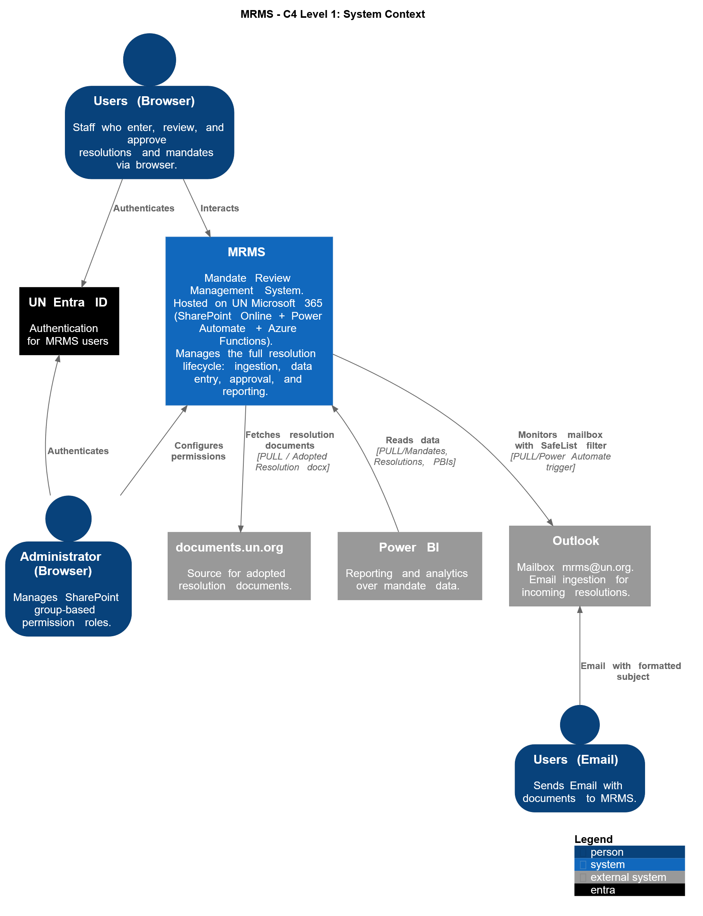

2. Architecture Overview

2.1 Tenant Topology
MRMS is deployed on a single UN OICT Microsoft 365 tenant. Three environments exist within this tenant, each as an isolated SharePoint site collection with its own flows and Azure Functions instance:
Environment | Purpose
Stage | Development and integration testing
UAT | User acceptance testing and stakeholder sign-off
PROD | Live production system
There is no shared infrastructure between environments. Promoting a release involves deploying the SPFx package to the target environment's App Catalog, importing Power Automate solutions, and updating the corresponding Azure Functions instance.

2.2 Component Overview
MRMS is composed of four layers:

2.2.1 Presentation
SPFx Web Parts: Six web parts deployed to SharePoint pages, each serving a distinct function:
Web Part | Description
Resolution Dashboard | Overview of all resolutions; searchable by draft resolutions, session, year, OPs and comments
My Dashboard | Personalised view showing resolutions assigned to and progress of All Resolutions and PBIs
Add / Edit Resolution | Form for creating and editing resolution records, associated metadata and Mandates
PBI Forms | Three variants — Conference Services, OHCHR, Misc — for Programme Budget Implication data entry
Bulk Update | Allows batch costs updates and field updates across multiple resolution records. Update PBIs at different stages like Requested, Revised estimate, ACABQ and GA Approved
Oral Statement Generation | Generates and routes oral statements for approval based on approval process defined in Cost Rates excel file
Revised Estimate | Import OPs from doc file at https://documents.un.org and save it according to the Resolution and mandate.
All web parts are built with SharePoint Framework (SPFx) and deployed site-wide via the Site collection App Catalog. Lazy loading is applied to Resolution dashboard webpart to keep initial page load within acceptable thresholds.

2.2.2. Workflow
Power Automate: Flows handle all automated processing: email ingestion from the mrms@un.org mailbox, generation of Resolutions based on emails and documents, extracting OPs from documents via Azure function trigger, approval routing, notifications, PBI processing, and bulk operations. Flows are maintained as individual flows for each functionality and for each environment.

2.2.3 Backend
Azure Functions: A serverless API layer called directly by SPFx web parts or Flows over HTTPS. Handles operations that cannot run client-side, such as generation of Oral statement word document based on JSON passed in the body, extracting of Operative paras from attached document, generation of Revised estimate report. Authenticates to SharePoint using App-only credentials (Client ID and Secret).

2.2.4 Data
SharePoint Lists & Libraries: All application data is stored in SharePoint Lists and Libraries within the site collection. No external database is used. Key stores include Resolutions, Mandates, OPs, PBI lists, Status, CostRates, Error Logs, and document sets for generated files.

2.3 Component Interactions
User (browser)
│
▼
SPFx Web Parts (SharePoint page)
│── reads/writes ──▶ SharePoint Lists & Libraries
│── calls HTTPS ───▶ Azure Functions API
│ │── Entra ID App Reg ──▶ SharePoint Lists & Libraries
│
▼
Power Automate (event-triggered)
│── monitors ──▶ mrms@un.org mailbox (Outlook)
│── reads/writes ▶ SharePoint Lists & Libraries
└── sends ──────▶ Notifications (M365 mail)

Power BI
└── reads ──────▶ SharePoint Lists & Libraries

3. Data Architecture

3.1 Overview
All MRMS application data is stored in SharePoint Lists and Libraries within the site collection. There is no external database. Data is structured around a parent-child hierarchy:
Resolutions (Document Set Library)
└── Mandates
└── OPs (Operative Paragraphs)
└── PBI Lists (Conference Services / OHCHR / Misc)
Relationships are maintained via lookup columns using ResolutionID, MandateID, and BudgetSectionID as foreign keys across lists.

3.2 List & Library Descriptions
Store | Type | Purpose
Resolutions | Document Set Library | Each Resolution is a Document Set. Stores resolution metadata and contains uploaded files (Word documents received from email; generated Oral Statement files; and any additional supporting files).
Mandates | List | Stores Mandate records linked to a Resolution via ResolutionID. A resolution can have one or more mandates.
OPs | List | Operative Paragraphs extracted from the incoming draft resolution document, linked to a Mandate via MandateID.
Conference Servicing data | List | SRMandateExtension, MeetingsServices, DocumentServices lists keep entries for Conference Services, linked to Resolution and Mandate via ResolutionID and MandateID.
Non-Conference Servicing-related data (e.g. OHCHR) | List | PostnStaffCosts, TravelandContributions, ConsultantExperts, Other Services lists keep track of PBI entries for OHCHR and Other Budget Sections linked to Resolution and Mandate via ResolutionID and MandateID. Another column BudgetSectionID keeps track of Budget Section to use it for fetching data as per this filter via rest api calls.
Status | List | Lookup list defining valid resolution and workflow statuses for each data entry form and Oral Statement. This list is used in My Dashboard to show workflow approval stages.
CostRates | Library | Excel files defining cost rates and effective-date logic used by the Oral Statement generation, PBI calculation, approval process, and Revised Estimates report generation processes.

3.3 Data Relationships
Resolutions (Document Set Library)
│ ResolutionID (primary key)
│ Session, Year, IntergovtBody, AdoptedRes, DraftRes ...
│
├──▶ Mandates
│ MandateID (primary key)
│ ResolutionID (lookup → Resolutions)
│ MandateTitle, MandateType ...
│
│ └──▶ OPs
│ OPID (primary key)
│ MandateID (lookup → Mandates)
│ OPText, OPNumber ...
│
│ └──▶ PBI Lists (Conference / OHCHR / Misc)
│ MandateID (lookup → Mandates)
│ BudgetSectionID (primary key)
│ TotalCosts, ApprovedTotalCosts, Quantity, frequency, location, type, recurrency ...
│
└──▶ Document files (within Document Set)
As Received (.docx)
Oral Statement (.docx, generated)
Approved Oral Statement (.pdf, generated)
Supporting files (any format)

3.4 Data hierarchy diagram
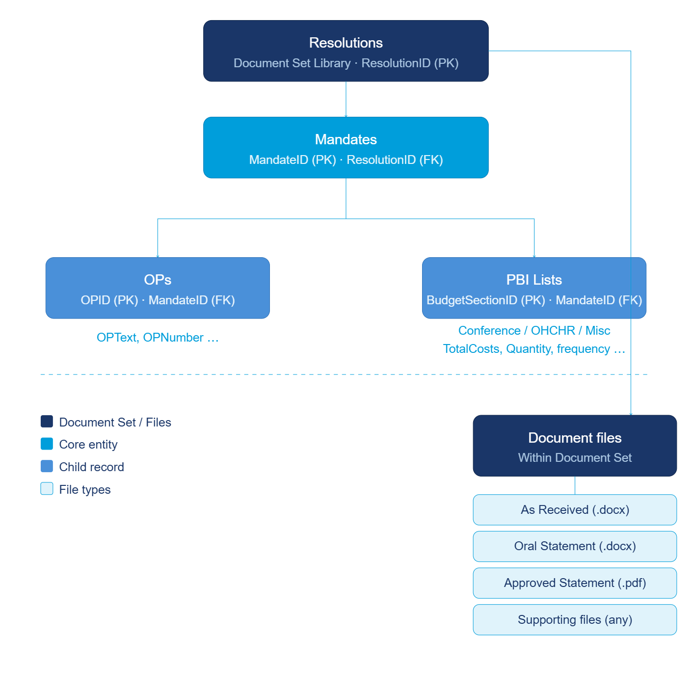

3.5 Data Lineage
The typical data flow through the system follows this sequence:
- Resolution created: either manually via Add/Edit Resolution form, or automatically via email ingestion (Power Automate monitors mrms@un.org and creates the Resolution record and Document Set). Notifications are sent to pre-defined groups and an approval is sent to DCM MMS permission group.
- OPs extracted: Power Automate triggers an Azure Function to extract Operative Paragraphs from the attached document and saves them against the Resolution. On the Edit Resolution page, users create the Mandates and associate the extracted OPs with the Mandates.
- PBIs entered: Users complete PBI forms (Conference Services, OHCHR, Other PBI) linked to specific Mandates and OPs. PBI records progress through approval stages which are pre-defined from the CostRates Excel file, depending on the Budget Section.
- Oral Statement generated: Similar to PBIs, the Oral Statement goes through an approval process and can be re-generated or updated at various stages in the approval process from the data contained in the PBI data entry forms. When generate button is clicked, Azure Function receives resolution metadata as JSON, merges it with CostRates data, and produces a Word document stored back in the Resolution Document Set. Once the Oral Statement is approved at the final stage, the System gives option to generate the PDF version of the Word document, which is likewise stored in the Resolution Document Set.
- Reporting: Power BI reads directly from Resolutions, Mandates, OPs, and PBI lists to produce dashboards and summary reports.

3.6 Data Dictionary
A full column-level data dictionary (internal names, display names, types, and constraints) is maintained separately. The table below documents key relationship and identity columns across the core lists.
List | Column | Internal Name | Type | Notes
Resolutions | Resolution ID | ResolutionID | Text | Primary key, auto-generated
Resolutions | Session | Session | Text | Intergovernmental body session
Resolutions | Resolution Status | ResolutionStatus | Text | Adopted Resolution Status
Mandates | Resolution ID | ResolutionID | Resolutions | Foreign key
Mandates | Mandate ID | MandateID | Text | Primary key
OPs | Resolution ID | ResolutionID | Resolutions | Foreign key
OPs | Mandate ID | MandateID | Mandates | Foreign key
OPs | OP Number | OPNumber | Number | Para sequence within mandate
PBI (all) | Resolution ID | ResolutionID | Resolutions | Foreign key
PBI (all) | Mandate ID | MandateID | Mandates | Foreign key
PBI (all) | Budget Section ID | BudgetSectionID | Text | Primary key
PBI (all) | Total Cost | TotalCosts | Number | The final cost of the PBI
Status | Approval Status | ApprovalStatus | Choice | Stores the current status of PBI form

4. Process & Workflow Design

4.1 Resolution Lifecycle
A resolution moves through the following states. Transitions are driven by user actions in the SPFx forms and Power Automate flows.
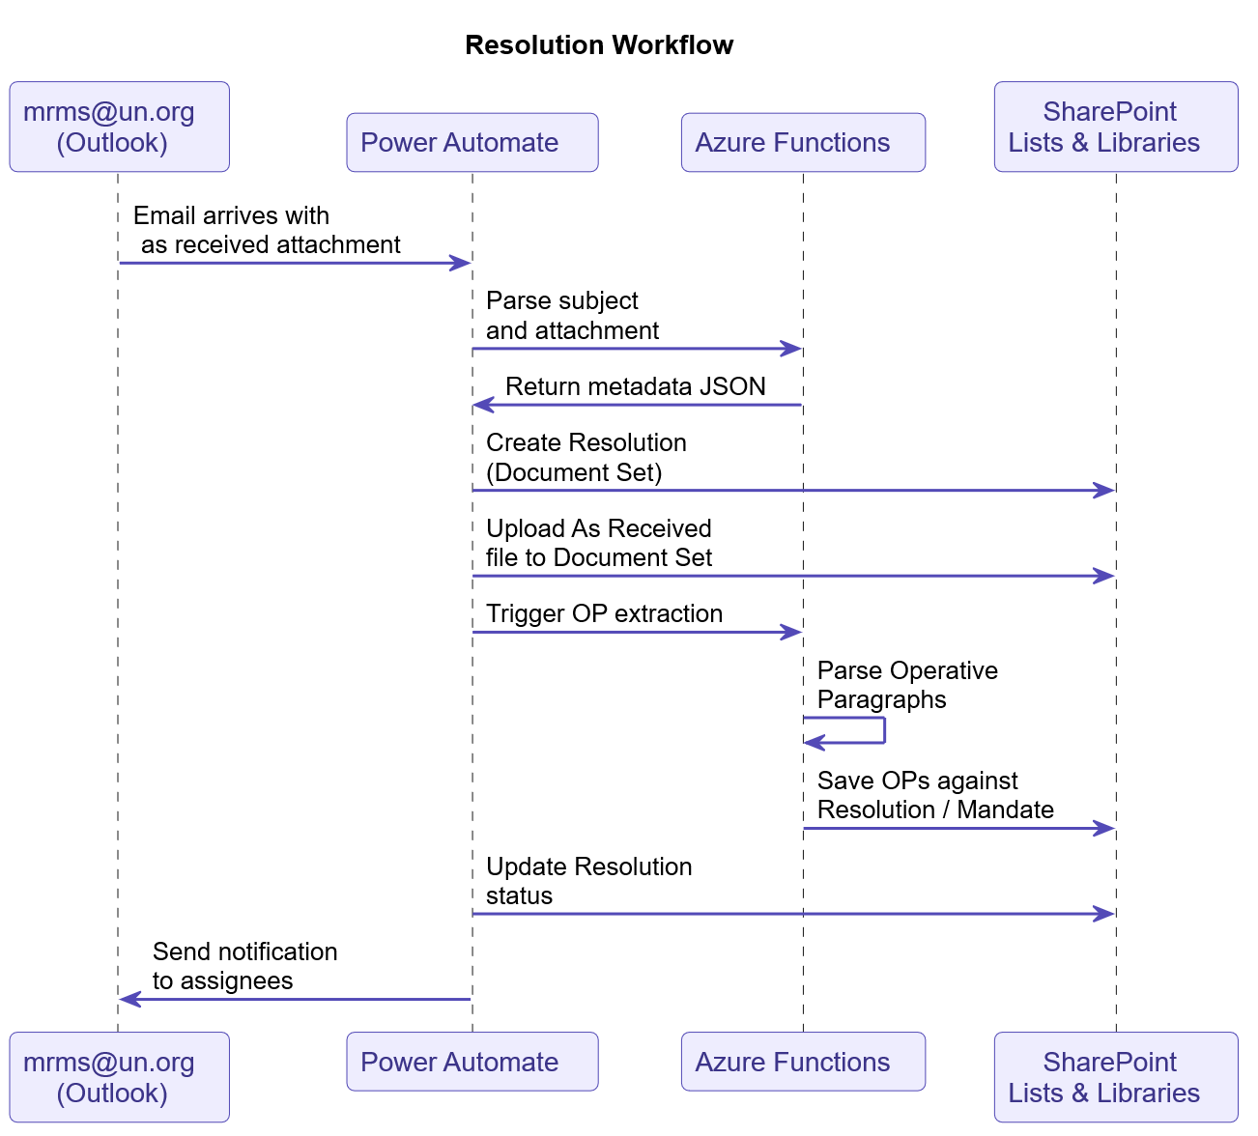
State | Description
Draft | Resolution created but not yet submitted for approval
Approved | Resolution formally approved
Rejected | Returned and requires rework before resubmission
Withdrawn | Resolution withdrawn after approval
Amended | Approved resolution subsequently amended
Corrected | Technical correction applied to an approved resolution

4.2 PBI Entry & Approval Stages
PBI records are created per Mandate and progress through approval stages defined in the cost rates file according to the Budget section. Each stage is managed via the relevant PBI form (Conference Services, OHCHR, or Misc).
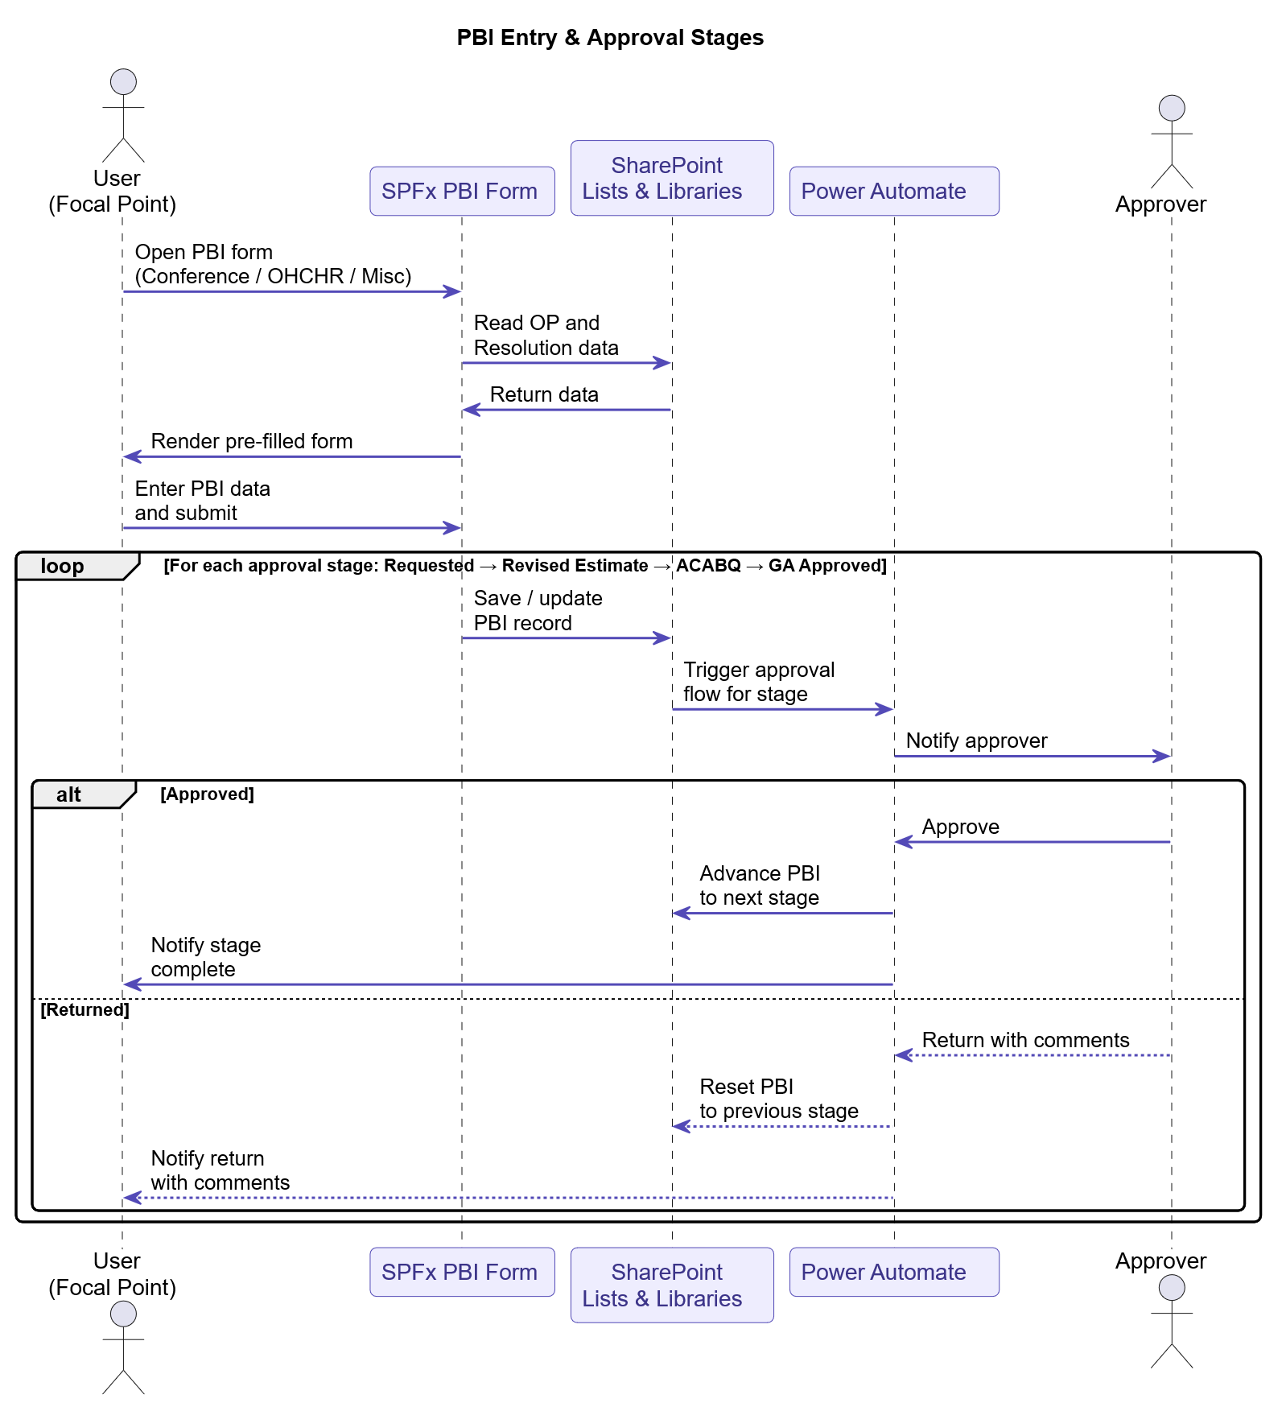

PBI approval stages:
Stage | Description
Requested | Initial PBI submission by focal point
Revised Estimate | Updated cost estimate submitted for review
ACABQ | Advisory Committee review stage
GA Approved | Final General Assembly approval

4.3 Oral Statement Generation & Approval
Triggered manually by an authorised user from the Resolution Dashboard or Add/Edit Resolution form.
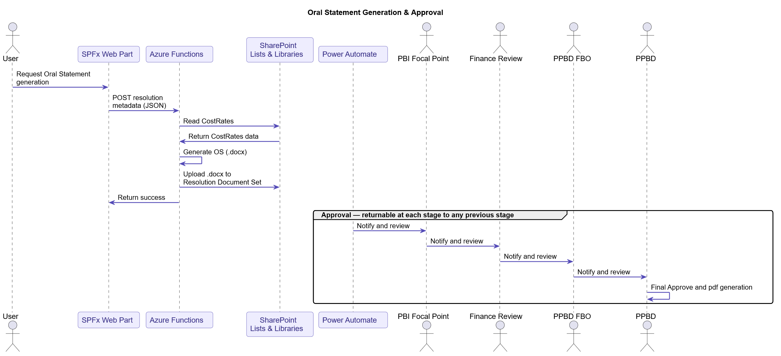

Approval stages and return behaviour (example):
Stage | Actor | On Approval | On Return
1 | PBI Focal Point | Advances to Finance | Returns to PBI Focal Point
2 | Finance Review (Approver) | Advances to PPBD FBO | Returns to Finance Review
3 | PPBD FBO | Advances to PPBD | Returns to any prior stage
4 | PPBD | Final approval | Returns to any prior stage

A return at any stage resets the OS status and notifies the relevant party, via email, to revise and resubmit.

4.4 Revised Estimate Generation
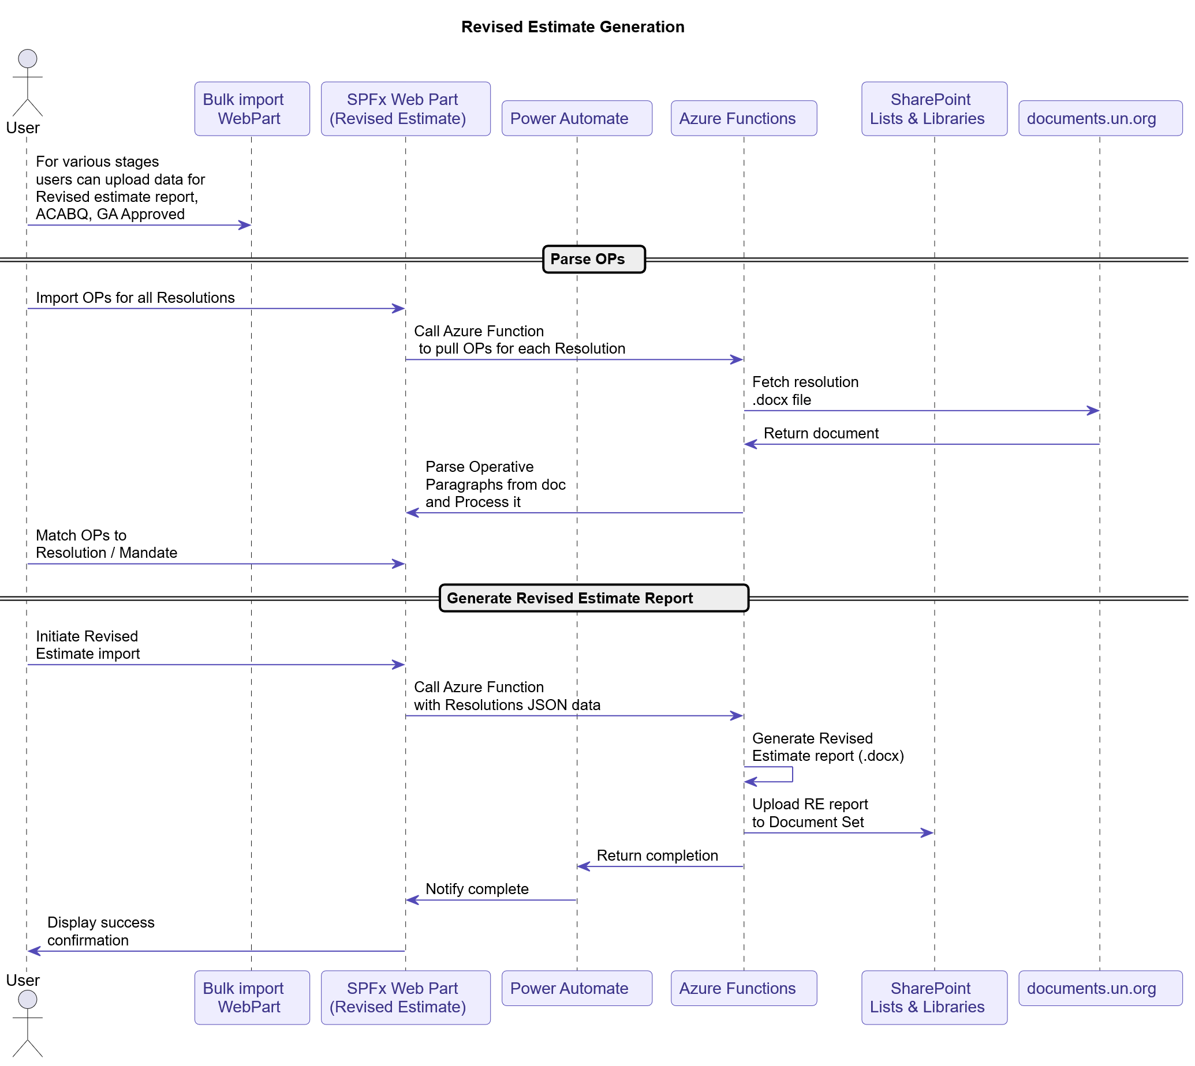
Triggered from the Revised Estimate web part by an authorised user.

5. Configuration Artifacts

5.1 Overview
MRMS has a single configuration artifact: the CostRates Excel workbook, stored in the CostRates document library on the MRMS SharePoint site. This workbook is the system's source of truth for all runtime configuration — cost rates, approval chain definitions, form dropdowns, column headers, calculation formulas, document generation values, OP parsing rules, and budget section mappings.
No code changes are required to update rates, add budget sections, change approval chains, or modify form options. All such changes are made by uploading a new version of the workbook.
File read convention: MRMSRates_YYYY.xlsx (e.g. MRMSRates_2026.xlsx), the Costrates document library has 3 columns – EffectiveFrom, ValidTillDate and TypeofFile. Based on the current date and columns, the SPFx webparts read the file which falls within the filter and the first file is picked to read the configuration.
Stored in: CostRates SharePoint document library — SharePoint versioning is enabled.
Access control: Only users in the MRMS Owners permission group may upload new workbooks.

5.2 Workbook Sheet Groups
The workbook contains 56 sheets organised into the following functional groups. Sheets marked (annual) must be reviewed and updated each year.

Group 1 — Tabs Update Guide
These sheets list which other sheets require annual review. They serve as a maintenance checklist for the person responsible for updating the file each year.
Sheet | Purpose
Sect. 24 OHCHR Tabs List | Lists OHCHR sheets to update annually
Sect. 2 DGACM Tabs List | Lists DGACM sheets to update annually
Sect. 28-29E DGC-DoA Tabs List | Lists DGC/DoA sheets to update annually

Group 2 — Reference Lookup Tables (annual)
Provide the underlying data used by cost calculation formulas. These must be updated annually or whenever UN rates change.
Sheet | Key Columns | Purpose
Locations | D/S code, City, Country | Maps D/S codes to city and country. Used in travel and DSA rate lookups
Travel rates | Departure, Destination, Mode, Key, Standard Ticket Price | Point-to-point travel costs by transport mode (Economy/Business)
DSA rates | Destination code, City, DSA Rate (short/long term) | Daily Subsistence Allowance by destination
Terminal exp | Departure, Destination, Terminal Rate | Terminal expenditure amounts
Salary scales | BudgetSection, Entity, Job Code, Time, Version, Rate columns | (Primary) Staff salary rates per entity, job code, and biennium
Salary scales ALL | Entity, Job Code, Time, Rate columns | Cross-entity salary reference
Salary scales DGACM | Entity, Job Code, Time, Rate columns | DGACM-specific salary scales
Salary scales (2022) | Entity, Job Code, Time, Rate columns | Historical 2022/2023 salary reference
Exchange rates | Effective Date, CHF/USD, EUR/USD | Currency conversion rates with effective date for time-based selection
Job Codes | Job Code, Job Family, Job Network, Level | UN job code reference table
Entities | Acronym, Name, Location, Budget Section | Entity acronym to full name and budget section mapping
Budget Section vs ENTITY list | Budget Section, Section Name, Entity Full Name, Acronym | Maps budget section numbers to all associated entities
DS | Country, City, Category, Hardship, Non-family service, Danger Pay | Country classification and allowance categories

Group 3 — Cost Rates (per entity/budget section)
Each sheet defines the billable cost items for a specific entity and budget section. These are the rates consumed by Azure Functions during PBI cost calculation and Oral Statement generation.
Standard column structure across all Cost_Rates sheets:
Column | Description
Resource Category | High-level cost type (e.g. Posts, Travel, Contractual services, Webcasting)
Resource Subcategory | Specific line item (e.g. Posts - New, GTA - Short Term)
Item/Location | Further qualifier (e.g. Switzerland Geneva, New York)
Servicing Duty Station | Where applicable (DGACM, DGC)
Budget Class | UN budget class code (e.g. Class 010, Class 015, Class 120, Class 125)
Commitment Item | Cost center sub-code
Entity / Entity Name | Owning entity acronym and full name
Budget Section | UN budget section number and name
Cost Center | SharePoint cost center code
Currency | Billing currency (USD)
Unit rate | Cost per unit (numeric or "Derived or manual")
Unit | Rate unit (YEAR, DAY, WORD, HOUR, MONTH)
Calculation Formula | Human-readable formula (e.g. Cost = # of staff x # of months)
Comments | Notes on rate applicability, proration, exceptions

Sheet | Budget Section | Entity
Cost_Rates OHCHR | Section 24 | OHCHR — Human Rights
Cost_Rates OLA | Section 8 | OLA — Legal Affairs
Cost_Rates DGACM | Section 2 | DGACM — General Assembly / Conference Services
Cost_Rates DGC | Section 28 | DGC — Global Communications / Webcasting
Cost_Rates DSS | Section 34 | DSS — Safety and Security
Cost_Rates UNOG | Section 29E | UNOG — Administration Geneva
Cost_Rates ALL | All sections | Consolidated view of all entity cost rates

Group 4 — Approval Chain Configuration
Defines the approval workflow for each budget section. The SPFx web parts and Power Automate flows read this configuration at runtime to determine who approves what, in what order, and under what conditions. Approval chains can be changed without any code modification.
Approvals sheet columns:
Column | Description
BudgetSectionName | Key identifying the budget section or form type (e.g. Section 24, CONFSERV, OS)
Entity | Entity acronym the row applies to
Draft | Yes/No — whether the approver can send the PBI back to Draft status
CanRecall | Yes/No — whether the approver can recall the form to a prior stage
DeletePBI | Yes/No — whether the approver can delete the PBI record
CONDITIONS | Semicolon-separated condition codes that must be met for this step to be included in the workflow (blank = always applies)
Order | Numeric sequence of the approval step (supports sub-steps, e.g. 3.1, 3.2)
WF | SharePoint group name assigned as the approver for this step
AddNotification | JSON object defining conditional notification rules for the step

Defined approval chains:
BudgetSectionName | Steps | Notes
Section 24 (OHCHR) | 1 → 2 → 3.1 → 3.2 → 4 → 5 | OHCHR Substantive Staff → PBI FP → Finance Reviewer → Finance Approver → PPBD FBO → PPBD OD
CONFSERV (Conference Services) | 1 → 2 → 3 → 4 → 5 → 6.1 → 6.2 → 7 → 8 | Includes conditional steps for webcasting, accessibility, audio recording, non-Geneva meetings
OS (Oral Statement) | 1 → 2 → 3.1 → 3.2 → 4 → 5 | OHCHR Division → PBI FP → Finance Reviewer → Finance Approver → PPBD FBO → PPBD OD
Section 8 (OLA) | 1 → 2 → 3.1 → ... | OLA Substantive Staff → PBI FP → Finance Reviewer chain
SAMPLE | Template row | Reference example showing the column schema

ApprovalDetails(Draft) sheet — documents the condition code logic used in the CONDITIONS column:
Condition Code | Trigger
SR_MANDATE | SR_MandateExtension record exists with TotalDoc > 0
STD_DOC | DocServices Standard Report column applies
NONSTD_DOC | DocServices Non-Standard Report column applies
ACCESSIBILITY | MeetingServices Accessibility Services > 0
WEBCASTING | MeetingServices Webcasting column applies
AUDIO_REC | MeetingServices Audio Recording column applies
NON_GVA | Meeting location city is not Geneva
INTRP_LESSTHAN6 | Meeting interpretation language count < 6
POST_GTA_12M_GVA | Post or GTA >= 12 months in Geneva

Group 5 — Form Configuration (per entity/section)
Provides all UI-level configuration consumed by the SPFx PBI forms. No form labels, dropdowns, or default values are hardcoded in the SPFx solution.
Sheet | Purpose
DropdownValues ALL | Dropdown options for all sections: Type (New/Perennial/Termination), Recurrent, Provision Year, Document types, Standard estimate sizes
DropdownValues OHCHR-General | OHCHR-specific dropdowns: months, cost centres, status values
DropdownValues DGACM | DGACM-specific dropdowns: captioning languages, document types
DropdownValues UNOG | UNOG Section 29E dropdowns: resource categories and sub-categories
Headers OHCHR-MISC | Column header display names for OHCHR and Miscellaneous PBI form tables
Headers DGACM | Column header display names for DGACM (Section 2) Conference Services form tables
Headers ALL | Combined header definitions across all form types
Categories OHCHR-MISC | Resource category/subcategory taxonomy with UN commitment items — defines rows in OHCHR/Misc PBI forms (Posts, GTA, Consultants, Experts, Travel, Grants, Contractual Services, etc.)
Standard Values OHCHR | Default formula values for OHCHR forms (e.g. multileg trip standard rate, DSA default)
Standard Values DGACM | Default formula values for DGACM forms (e.g. terminal expenditure default, meeting duration threshold)
Standard Values ALL | Consolidated standard values across all sections
DefaultValues DGACM | Pre-populated field defaults for DGACM form sections (location, meeting type defaults)
CostFormula OHCHR | Named formula definitions for OHCHR cost calculations
CostFormula DGACM | Named formula definitions for DGACM cost calculations
CalculationFormulas | Full formula lookup table: Section → Category → Subcategory → Cost type → Lookup fields → Formula expression

Group 6 — Application / System Mappings
Consumed by the SPFx web parts to resolve which SharePoint lists, columns, and budget section identifiers apply to each form and entity combination.
Sheet | Purpose
SummaryTable | Master mapping: BudgetSection → Form type → BudgetSectionName → Entity → BudgetSectionID → SharePoint List names. Primary lookup used by SPFx to know which lists to read/write for a given budget section
ConfServForm_Mappings | Maps Conference Services form fields to specific SharePoint list internal names and column names. Covers both General PBI (Type=General) and Revised Estimate variants (Type=RevisedEstimates). Includes internal list name, SP.Data.* type for REST calls, column name, budget section, and PBI change column

Group 7 — Document Generation Values
Provides the static field values and template configuration used by Azure Functions when generating Oral Statement and Revised Estimate Word documents.
Sheet | Key Columns | Purpose
OS values | Item #, FIELD_name, VALUE | Static field values injected into the Oral Statement .docx template: recipient name/position, sender name/position, Cc list, GA session number, reference resolution symbol and date. Updated each biennium
RE values | Item #, FileTemplate, FIELD_name, VALUE, Comment | Field mappings per RE template file: GA session number, regular and special session lists and dates, HRC report symbols, staff assessment percentage, unforeseen expenses resolution reference
RE values Annex III | Year, Session, Resolution counts, Mandate counts, Requirements | Historical data table for the Revised Estimate Annex III statistical summary

Group 8 — OP Parsing Configuration
Controls how Azure Functions identifies and normalises operative paragraph trigger verbs when parsing resolution .docx files.
Sheet | Columns | Purpose
ParsingTransform | Parse, Transform | Two comma-separated keyword lists: Parse — verbs that trigger OP identification (e.g. Adopts, Approves, Authorizes, Decides, Endorses...); Transform — normalised output verb forms used when saving OPs to SharePoint (e.g. Adopts, Affirms, Appeals, Approves...)

Group 9 — Sample Form Templates
Embedded sample/template form sheets for reference and manual testing. These sheets are not consumed by the application at runtime.
Sheet
Sect 2 (Conference Services)
Sect 24 (Human Rights)
Sect 29E (Administration)
Miscellaneous PBI
Details breakdown

5.3 Annual Update Process
The following sheets must be reviewed and updated at the start of each biennium or annual budget cycle:
Priority | Sheets | Trigger
Mandatory | Salary scales, Salary scales ALL, entity-specific salary scales | New UN salary scales published
Mandatory | Travel rates, DSA rates, Terminal exp | ICSC or UN travel rate updates
Mandatory | Exchange rates | Annual treasury rate update
Mandatory | OS values | New GA session number, updated recipient/sender details
Mandatory | RE values | New GA session, session dates, HRC report symbols
As needed | Cost_Rates * (per section) | Budget class or unit rate changes per entity
As needed | Approvals | Changes to approval chain for any budget section
As needed | DropdownValues *, Categories OHCHR-MISC | New resource categories, cost types, or option values added
As needed | SummaryTable, ConfServForm_Mappings | New budget section or SharePoint list onboarded

Once updated, the new file is uploaded to the CostRates SharePoint library. The previous version is retained automatically via library versioning. No code deployment is required — the application reads the latest file at runtime.

6. Security & Compliance

6.1 Authentication
All user access to MRMS is authenticated via UN Entra ID using OAuth 2.0. SharePoint Online enforces authentication natively — users who are not members of the UN OICT tenant cannot access the site. There is no separate login mechanism within MRMS.
Azure Functions authenticates back to SharePoint using Entra ID App Registration with certificate-based MSAL (msal.ConfidentialClientApplication). This is implemented and active in all environments — no client secrets are used.
All three Azure Functions (generate_os_files, parser, generate_revest) authenticate to SharePoint using the same Entra ID App Registration. Authentication is performed via msal.ConfidentialClientApplication with a PFX certificate loaded at runtime. The required environment variables are: uat_TenantID, uat_ClientID, uat_Url, uat_CertPassword.
Outstanding security item: The PFX certificate file (mrms-prod.pfx) is currently stored in the source repository. It should be migrated to Azure Key Vault so that functions load the certificate at runtime via a Key Vault reference, eliminating the certificate from source control (tracked as KI-007).

6.2 SharePoint Permission Groups
MRMS uses SharePoint group-based permissions. All group memberships are managed by the MRMS Administrator in the SharePoint site settings. User provisioning and Entra ID group management are out of scope and handled by UN OICT.
Group | Permission Level | Description
MRMS Owners | Full Control | Site collection administrators and developers
MRMS Approvers | Contribute + Approve | Users authorised to approve resolutions and PBIs
MRMS Contributors | Contribute | Staff who enter and edit resolution and PBI data
MRMS Readers | Read | Read-only access to dashboards and reports
MRMS Administrators | Site Collection Administrator | Manages group memberships and site configuration

6.3 Object-Level Permissions
The following object-level permission overrides are applied within the site collection:
Object | Override | Reason
CostRates Library | Restricted to MRMS Owners | Prevent unauthorised updates to cost rate files
Error Logs list | Read for Contributors, Full Control for Owners | Contributors can view their own errors; only Owners can delete
SafeList | Restricted to MRMS Administrators and Owners | Prevent unauthorised email sender whitelisting
Site contents page/any other administrative page | Sharepoint permissions to these pages | SPFx extension deployed which checks the “SitePermissions” list and if a user browse to pages which contains words as below then they are redirected to home page.  Resolutions, viewlsts, /Lists /,/Forms /,CreateSitePage.aspx, sitepagepreview.aspx, user.aspx, siteanalytics.aspx

6.4 Data Classification & PII
MRMS handles internal UN administrative data related to budget planning and mandate management. Key classifications:
Data Type | Classification | Notes
Resolution metadata | Internal | Session, year, mandate data — not publicly sensitive
PBI cost figures | Internal | Budget data; restricted to appropriate approval groups
CostRates workbook | Internal | Contains internal UN cost formulas and rates
User email addresses (SafeList) | Internal | Email addresses of UN staff and approved senders
Oral Statements (generated .docx) | Internal | Pre-approved documents; access restricted to approval chain

No personal data beyond standard UN staff work accounts (names, email addresses in SharePoint Person columns) is stored in MRMS. Retention and labelling policies are governed by UN OICT and applied at the tenant level.

6.5 Audit & Monitoring
Event | Mechanism | Location
SharePoint list item create/edit/delete | SharePoint native audit log | SharePoint Unified Audit Log (M365 Admin)
SPFx client-side errors | Custom error logger | MRMS Error Logs list
Power Automate flow run history | Power Automate native run history | Power Platform Admin Centre
Document uploads to Document Sets | SharePoint version history | Per document library
MRMS relies on the native audit capabilities of Microsoft 365, SharePoint Online, Power Automate, and Azure Functions. No custom audit framework is implemented — all audit data is captured by platform-native mechanisms and is available to MRMS Owners and UN OICT administrators. The table below summarises the auditable events and their capture mechanism.

7. Non-Functional Requirements

7.1 Performance
Requirement | Target | Notes
Initial page load (Resolution Dashboard) | ≤ 10 seconds | Lazy loading applied to Resolution Dashboard web part
Form load (Add/Edit Resolution) | ≤ 10 seconds | Data fetched via SharePoint REST API on demand
Azure Function response time (OS generation) | ≤ 10 seconds | Dependent on document size and CostRates lookup
Azure Function response time (OP extraction) | ≤ 15 seconds | Dependent on resolution .docx size
Power Automate email ingestion trigger | ≤ 5 minutes from email arrival | Subject to Power Automate trigger polling interval

Lazy loading is implemented on the Resolution Dashboard web part to keep the initial page load within target. All other web parts load data on demand via REST calls scoped to the user's current context.
Caching is implemented on User Dashboard webpart to retain the user selected tab

7.2 Availability
MRMS inherits the availability SLA of its underlying Microsoft 365 and Azure platform components:
Component | SLA (Microsoft)
SharePoint Online | 99.9%
Power Automate | 99.9%
Azure Functions (Consumption Plan) | 99.95%

There is no MRMS-specific HA or failover configuration. Availability targets align with the UN OICT M365 tenant SLAs. Planned maintenance is communicated via OICT channels.

7.3 Capacity & Concurrency
Metric | Limit | Notes
SharePoint List items per list | 30 million items | Microsoft platform limit; not a practical concern for MRMS volumes
SharePoint List View Threshold | 5,000 items per view | All list views must use indexed columns and filtered views to stay within threshold
Azure Functions concurrent executions | 200 (Consumption Plan default) | Sufficient for expected MRMS load
Power Automate flow runs per day | Subject to M365 licence limits | Monitor via Power Platform Admin Centre
Simultaneous users | ≤ 100 concurrent | Based on expected UN UNOG conference services team size

All SharePoint list queries in SPFx web parts use indexed columns (ResolutionID, MandateID, BudgetSectionID, Session, Year) and REST API $filter and $select parameters to avoid exceeding the list view threshold.

7.4 RPO / RTO
Scenario | RPO | RTO
SharePoint Online data loss | 14 days (M365 recycle bin) | < 4 hours (admin restore)
Azure Function code loss | Last committed version in source repo | < 2 hours (redeploy from repo)
Power Automate flow loss | Last exported solution package | < 2 hours (reimport solution)
Full site collection loss | Subject to OICT backup policy | Coordinate with OICT

7.5 Browser Support
MRMS supports all modern browsers compatible with SharePoint Online SPFx:
Microsoft Edge (Chromium) — primary supported browser
Google Chrome (latest)
Mozilla Firefox (latest)
Safari (latest, macOS/iOS)
Internet Explorer is not supported.

8. Extensibility & Customization

8.1 Adding a New PBI Budget Section
MRMS is designed to accommodate new Budget Sections without significant code changes. The following steps are required to onboard a new section:
1. CostRates workbook — Add the new budget section to the SummaryTable sheet with the correct Form type, BudgetSectionID, and SharePoint list mappings. Add corresponding rows to the Approvals sheet defining the approval chain. Add rows to the relevant Cost_Rates sheet for unit rates. Add dropdown values and headers to DropdownValues and Headers sheets as needed.
2. SharePoint lists — When the data is added/saved with new budget section, the BudgetSectionID will be created and saved in the appropriate lists.

8.2 Adding a New Cost Type or Resource Category
1. Add the new cost type row with the correct Category, Subcategory, and unit rate to the relevant Cost_Rates sheet in the workbook.
2. Add the corresponding category entry to the Categories OHCHR-MISC or equivalent categories sheet.
3. Upload the updated workbook with versioning. No code changes are required — the Azure Function reads the rates sheet dynamically at generation time.

8.3 Updating Document Generation Templates
1. To update static field values in Oral Statement documents (e.g. new GA session, new recipient): update the OS values sheet in the CostRates workbook and upload. If more dynamic data is to be added to the Oral statement then further code changes are required.
To Be: Summary table will be generated in new Excel file with specific sheets for each mandate, it will be generated along with the OS file and users can copy/paste the tables in OS from the Excel file.
2. To update Revised Estimate template values (e.g. session dates, HRC report symbols): update the RE values sheet.
3. To change the Word document template structure itself: update the .docx template files referenced by the Azure Function and redeploy the function.

9. Error Handling & Telemetry

9.1 Error Handling Strategy
MRMS applies a layered error handling approach across all components:
Layer | Approach
SPFx Web Parts | Try/catch blocks on all REST API calls; user-facing error messages displayed inline; errors written to the Error Logs list (To be updated)
Azure Functions | Structured exception handling with HTTP error responses (4xx/5xx); Exceptions returned back to the call response with error message
Power Automate | Flow-level error handling with Configure run after on each action; failed runs trigger a notification to the Flow owners mailbox
SharePoint REST API | HTTP status codes checked on all responses

9.2 Error Logs List
The Error Logs SharePoint list captures client-side errors from SPFx web parts.
Column | Type | Description
ErrorID | Text | From Error message or blank
WebPart | Text | Name of the SPFx web part where the error occurred
ErrorMessage | Text | Exception message
StackTrace | Multi-line Text | Full stack trace (truncated to 255 chars if needed)
UserLogin | Text | Login name of the user who encountered the error
Timestamp | DateTime | UTC timestamp of the error
ResolutionID | Text | Resolution context at time of error (if applicable)
Severity | Choice | Info / Warning / Error / Critical
Resolved | Boolean | Marked true once the error has been investigated and closed

9.3 Power Automate Error Handling
Each Power Automate flow is configured with:
— Run after failure handling on critical actions, handled automatically by PowerAutomate (SharePoint writes, Azure Function calls)
— Flow run history retained for 28 days (platform default)
— Failed runs flagged in the Power Platform Admin Centre for monitoring

9.4 Alerting
Alert | Trigger | Recipient
Power Automate flow failure | Flow error branch | MRMS Owners
Error Log item created with Severity = Critical | Power Automate trigger on Error Logs list | MRMS technical team
SharePoint storage > 80% of quota | OICT / SharePoint Admin Centre | UN OICT
The following alerts are configured to notify the MRMS technical team and administrators of system events that require attention. Alerts are delivered via email through Power Automate flows or SharePoint list triggers.

10. Code & Release Architecture

10.1 Repository Structure
The MRMS codebase is maintained across two repositories:
Repository 1 — Section2 - SPFx Solution
Section2/
src/
webparts/
addResolution/
bulkUploads/
miscellaneous/
section2/
section24
shared/
common/ #common classes
components/ #reusuable components used in webparts
models/ # TypeScript interfaces and types

services/ # SharePoint REST API service classes
startup/ # Loads when the webparts are initialized
utils/ # Helper functions, formatters
sharepoint/
solution/ # .sppkg deployment package

Repository 2 — MandateDashboard - SPFx Solution
MandateDashboard/
src/
webparts/
mDashboard/
revEstReport/
userDashboard/
webparts/
permissionCheck/
shared/
services/ # SharePoint REST API service classes
models/ # TypeScript interfaces and types
utils/ # Helper functions, formatters
sharepoint/
solution/ # .sppkg deployment package

Repository 3 — Azure Functions
ospython/
function_app.py # Main entry point (Python 3.11); imports sp_auth.get_sp_context()
functions/
function_app/ # Oral Statement generation
sp_auth.py # Shared Entra ID cert-based auth module (get_sp_context())
http_parser/ # Operative Paragraph extraction
http_rer/ # Revised Estimate report generation
requirements.txt
host.json
local.settings.json # Local dev settings (not committed)

10.2 Versioning
Artifact | Versioning Scheme | Location
SPFx solution (.sppkg) | Semantic versioning (MAJOR.MINOR.PATCH) in package-solution.json | App Catalog — version history retained
Azure Functions | Git tag on release commit (v1.0.0) | Azure Functions deployment slot or zip deploy
Power Automate flows | Solution versioning via Power Platform Solutions (recommended — pending implementation) | Exported as .zip solution packages per environment (To Be)
CostRates workbook | SharePoint library versioning (major versions) | CostRates document library

10.3 Deployment Process
Stage → UAT → PROD promotion steps: Done using CI/CD pipelines in bitbucket
Step | SPFx | Azure Functions | Power Automate
1 | Build .sppkg with target environment settings | Zip-deploy function app code to target Azure Functions instance | Export solution from source environment
2 | Upload .sppkg to target Site Collection App Catalog | Update Application Settings in Azure Portal (site URL, auth credentials) | Import solution into target Power Platform environment
3 | Deploy/upgrade the solution in the App Catalog | Verify function health via /api/health endpoint | Activate flows and verify connections
4 | Verify web parts load correctly on target site | Run smoke test (OP extraction, OS generation) | Trigger test email to staging mailbox and verify ingestion

All configuration differences between environments (site URLs, function URLs, mailbox addresses) are held in Bitbucket repository variables — no code differences exist between environments.

10.4 Local Development Setup
SPFx:
1. npm install in the SPFx repo root
2. gulp serve — launches local workbench connected to Stage SharePoint site
3. Use gulp bundle --ship and gulp package-solution --ship to produce .sppkg for deployment

Azure Functions:
1. Create local.settings.json with the following environment variables (obtain values from the MRMS Service Account admin): uat_TenantID (Entra ID tenant ID), uat_ClientID (DEV App Registration Client ID: 6746d574-090f-4a0b-9123-3410754d6333), uat_Url (Stage site URL), uat_CertPassword (PFX certificate password). Do not commit this file — it is in .gitignore.
2. pip install -r requirements.txt
3. func start — runs functions locally on http://localhost:7071
4. Use Stage SharePoint site for integration testing

10.5 CI/CD
CI/CD pipelines are configured, merge to Dev, Stage, UAT branches trigger deployment process and it automatically uploads the resources and apppkg file to Catalog library. It needs to be manually deployed from the App Catalog library on the specific environment
Stage | Tool | Steps
Build | GitHub Actions / Bitbucket DevOps | npm ci, gulp bundle --ship, gulp package-solution --ship
Deploy SPFx | Bitbucket DevOps release pipeline | Upload .sppkg to App Catalog via SPO REST API
Deploy Functions | None | Deploy manually via VS Code Azure Functions extension — sign in with Service Account, right-click function app → Deploy to Function App. Verify Application Settings (uat_TenantID, uat_ClientID, uat_Url, uat_CertPassword) in Azure portal after each deploy.

11. Appendices

11.1 Glossary
Term | Definition
MRMS | Mandate Review and Management System — the application described in this document
SPFx | SharePoint Framework — Microsoft's model for building client-side web parts and extensions on SharePoint Online
OP | Operative Paragraph — action paragraphs extracted from a resolution document
OS | Oral Statement — a generated Word document summarising mandate costs for presentation
PBI | Programme Budget Implication — a cost estimate record linked to a mandate
RE Report | Revised Estimate Report — a generated document summarising updated cost estimates
CostRates | Excel workbook stored in SharePoint defining cost rates, approval chains, form configuration, and document generation values
SafeList | SharePoint list of permitted sender email addresses for the email ingestion workflow
Document Set | A SharePoint content type that groups related documents into a folder-like container with shared metadata
Intergovernmental Body | A UN body (e.g. General Assembly, Human Rights Council) that adopts resolutions
UNOG | United Nations Office at Geneva
OICT | Office of Information and Communications Technology (UN)
PPBD | Programme Planning and Budget Division
FBO | Financial Budget Officer
ACABQ | Advisory Committee on Administrative and Budgetary Questions
OHCHR | Office of the United Nations High Commissioner for Human Rights
DGACM | Department for General Assembly and Conference Management
DCM | Division of Conference Management
DGC | Department of Global Communications
DSS | Department of Safety and Security
OLA | Office of Legal Affairs
CONFSERV | Conference Services — internal BudgetSectionName key used in the Approvals and SummaryTable sheets for Section 2
BudgetSectionID | Unique key combining budget section and entity acronym (e.g. S.24_OHCHR) used as the primary identifier for PBI records across SharePoint lists
Entra ID | Microsoft's cloud identity platform (formerly Azure Active Directory)
App-only Auth | Authentication mode where an application authenticates directly to SharePoint using its own identity (not on behalf of a user). In MRMS, all Azure Functions use Entra ID App Registration with certificate-based MSAL (msal.ConfidentialClientApplication). No client secrets are used in any environment.
Consumption Plan | Azure Functions hosting model where functions scale dynamically and billing is per execution
Correlation ID | A unique identifier assigned to a single transaction, used to trace it across multiple system components

11.2 SharePoint REST API Reference
Key REST API patterns used across MRMS:
Read list items with filter:
GET {siteUrl}/_api/web/lists/getbytitle('{ListName}')/items?$filter=ResolutionID eq '{id}'&$select=Id,Title,MandateID,ResolutionID&$top=5000
Create list item:
POST {siteUrl}/_api/web/lists/getbytitle('{ListName}')/items
Upload file to Document Set:
POST {siteUrl}/_api/web/getfolderbyserverrelativeurl('{folderUrl}')/files/add(url='{fileName}',overwrite=true)
Update list item:
POST {siteUrl}/_api/web/lists/getbytitle('{ListName}')/items({itemId}) — with X-HTTP-Method: MERGE and IF-MATCH: *

11.3 Azure Function Endpoints
Endpoint | Method | Caller | Description
/api/function_app | POST | SPFx (Oral Statement web part) | Generates Oral Statement .docx from resolution metadata JSON
/api/http_parser | POST | Power Automate | Extracts Operative Paragraphs from supplied .docx attachment
/api/http_rer | POST | SPFx (Revised Estimate web part) | Generates Revised Estimate report .docx

All endpoints accept and return application/json. Azure Functions authenticate to SharePoint via Entra ID App Registration (certificate-based MSAL) — implemented. Callers (SPFx web parts and Power Automate flows) authenticate to the function endpoint using a Function Key supplied in the code= query parameter, configured per environment.

11.4 Key Diagrams Index
Diagram | File | Description
C4 Level 1 — System Context | uml/1.system-context-diagram.puml | High-level actors and external systems
C4 Level 2 — Containers | uml/2.container-diagram.puml | Internal containers and their interactions
C4 Level 3 — Deployment (PROD As-Is) | uml/3.deployment-prod-diagram.puml | Production infrastructure topology
C4 Level 3 — Deployment (PROD — Entra ID Implemented) | uml/4.deployment-prod-diagram-tobe.puml | Production target state (Entra ID auth)
C4 Level 3 — Deployment (DEV As-Is) | uml/5.deployment-dev-diagram.puml | Dev/QA environment topology
C4 Level 3 — Deployment (DEV — Entra ID Implemented) | uml/6.deployment-dev-diagram-tobe.puml | Dev/QA target state (Entra ID auth)
Resolution Workflow | uml design/ResolutionWF.puml | Email ingestion to OP extraction sequence
PBI Entry & Approval | uml design/PBIWF.puml | PBI form submission and approval stages
Oral Statement Generation & Approval | uml design/OSWF.puml | OS generation and multi-stage approval
Revised Estimate Generation | uml design/RevEstReportWF.puml | OP import and RE report generation

